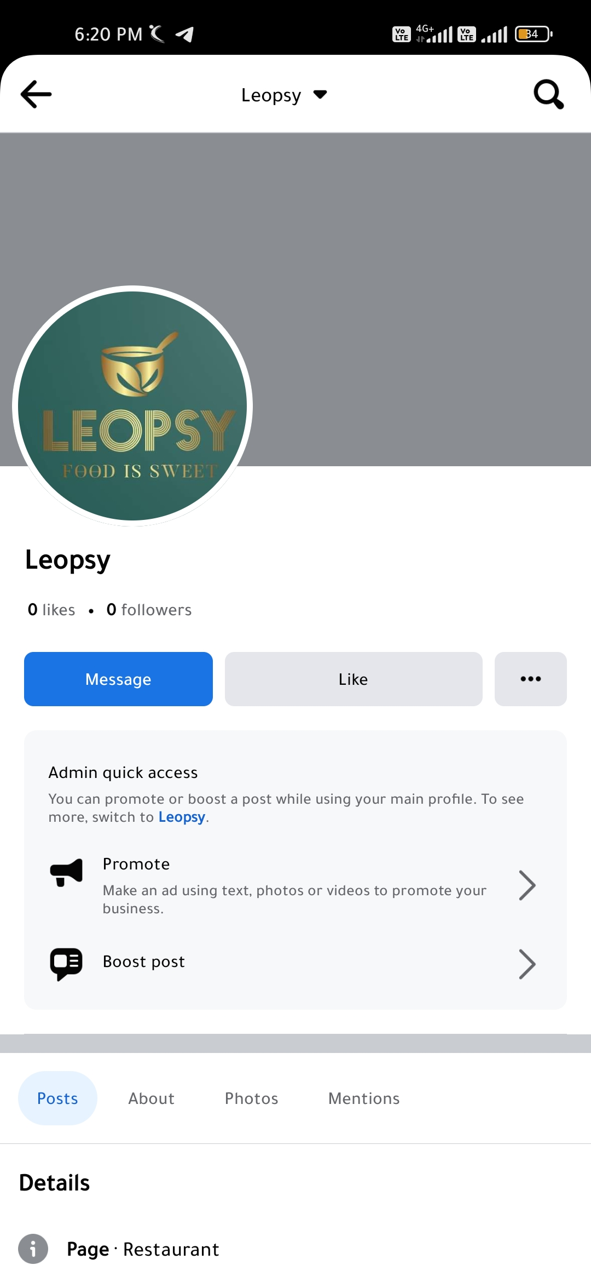**ASSIGNMENT-2**

Create a New Facebook Business Page and Post one social media poster for your brand.

|  |  |
| --- | --- |
| NAME | Jayapal .M |
| NM ID | 10BFD22FD91B9D5A6B649D2FCD4BB3F4 |
| ASSIGNMENT 2 | Create a New Facebook Business Page and Post one social media poster for your brand |

